Name: | Chaoyang Feng
Course Code: | GV101
Question attempted: | Political mobilization (NO.4)
Word Count: | 1544
Assessment title: | Is higher voter turnout good for democracy?

“Is higher voter turnout good for democracy?”

Introduction:
As most democratic systems move towards representative democracies (Day, 2021), elections become more important in the practice of democracy. This makes the participation of citizens in elections vital, as it can relatively prevent the manipulation of elections. Furthermore, to have a better measure of the participation rates of eligible citizens in elections, the index “voter turnout” is used. However, a question has been raised about democracy and voter turnout: is higher voter turnout beneficial to democracy? To figure out this question and find the relationship between voter turnout and democracy, this essay will first conduct some research by analyzing some data and providing visualized diagrams of them to tell whether the higher voter turnout necessarily means a better practice of democracy. Then, based on the data, this essay further assesses the limitations of the research, and applies political theory to best address the topic.

Data analysis:
First, by collecting data on the Democracy Index (DI) and Voter Turnout (VT) of 27 developed countries from the website Our World in Data (2023), three figures could be generated based on the collected data. Since the turnout data is not available every year for countries, the consistency and correspondence of DI and VT will be ensured by collecting from the same year for a country, where the year will be the number after the country code (e.g.: GBR19 means that both DI and VT data for the UK are collected in 2019). Aggregately speaking, both DI and VT are high in the figure, according to these two bar charts Figure 1 and Figure 2. This means the participation in elections and the extent of democracy in these 27 selected countries are relatively satisfactory.

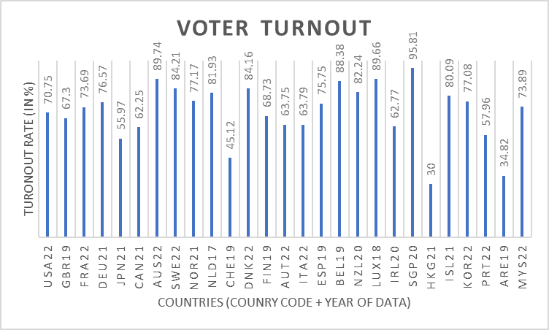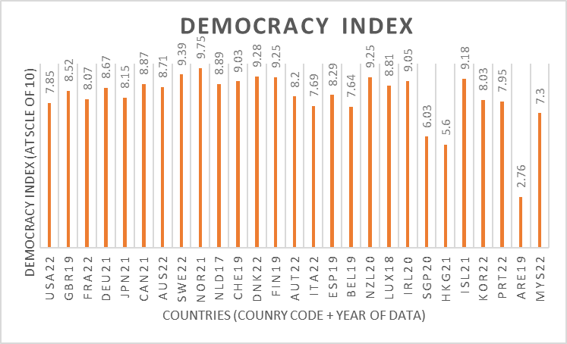
Figure 1 Figure 2
Note: voter turnout data for 27 developed countries. Note: democracy data for 27 developed countries.

In Figure 3, the relationship between VT and DI is represented by the plots. Each plot stands for a country and its distribution of data about its VT and DI on a 2-dimensional map. A trend line has also been drawn based on the positions of the 27 plots. The correlation coefficient for VT and DI, calculated from data, is +0.491731, which means that there is a moderate (neither strong nor weak) positive correlation between DI and VT. This positive correlation could also be deduced from the upward-sloping direction of the trend line in Figure 3 and its positive gradient. Supported by this research, the good statistics on voter turnout in elections may be beneficial for democracy.

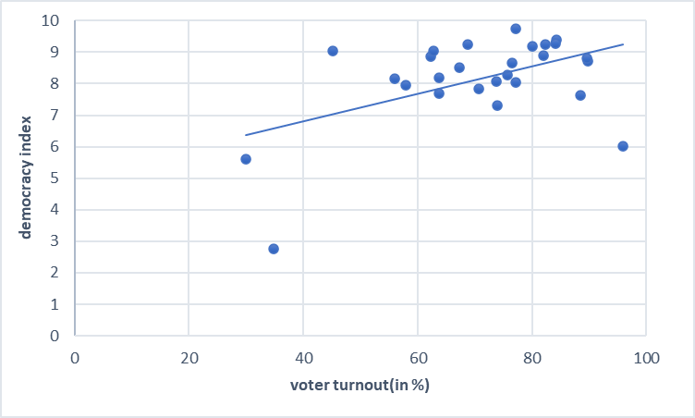
figure 3
Note: correlation between democracy index and voter turnout rate in 27 developed countries (not including Qatar because of no data in voter turnout).

The final observation about the data is: that compared to the rest of the world, these 27 developed countries have a much higher average democracy index (EIU, 2023). Moreover, most of them are democratic countries, although the forms vary within them. However, despite voter turnout rate is also relatively outstanding (Our World in Data, 2023), the gap between voter turnout and the average is smaller than the gap between these selected countries and all countries in terms of the democracy index. In simple words, the voter turnout rate is indeed higher, but the democracy index is much higher. Taking concern of the figure of correlation coefficient together, the link between voter turnout and democracy may not be strong.

However, there is also an opposite finding: including these 27 developed countries, participation in elections is optional in most countries, but still compulsory in a few, which means all the eligible candidates have both the right and the responsibility to vote. In other words, the voter turnout in these countries will be closer to 100% in contrast to places where voting is optional. Taking a sample of 11 countries (ARG, AUS, BOL, BRA, ECU, LUX, PRK, PER, SGP, URY, TUR) that still currently conduct compulsory voting policy in their elections, the average voter turnout rate from the past 5 years data is 84.5955% (Our World in Data, 2023). However, the average democracy index for these countries in the past 5 years is only 6.2969 (Our World in Data, 2023). By observing from the straight line in Figure 3 for the same 85% voter turnout on the x-axis, the democracy index for the 27 developed countries is roughly 8.5. By comparing these data, the previous data is about 2.2 units lower than the statistic of the democracy index (roughly 8.5) in Figure 3, given the same voter turnout data. This finding suggests that the high voter turnout rate in the countries/regions where mandatory voting is adapted does not always bring a corresponding better practice in democracy.

Limitations:
However, a limitation of these 2 studies is that voter turnout is not the only factor influencing democracy. To reduce this limitation, conducting qualitative research for a country before and after the year in which compulsory voting is introduced could offer some help. For Australia, the mandatory voting policy was first introduced in the Queensland state election of 1915, which later radiates to other areas of Australia. As a result, its voter turnout increased significantly from around 60% in 1922 to over 90% in 1925 (Our World in Data, 2023). The 2 main reasons for mandatory voting, as Electoral Commission Queensland (2021) suggests, are the financial burden and fairness problem. It is easy to understand that the Australian government spends extra money and effort to get citizens to vote, while the core problem I want to discuss here is: that the Commission claims that it is unfair to make a policy that influences all population while only involving part of the population to decide on the policy. And despite the Queensland Commission does not mention, I think the mandatory voting is also beneficial in involving the less represented group of people, which might include females, the ethnic minority, and the poor.

While this claim of fairness by the Queensland Commission seems to be intuitively correct, the reality is that the level of education is an important prerequisite in involving the entire population in voting (mandatory voting). More than 2000 years ago, Plato argued that the state should be ruled by few people (philosopher kings) who can prove their qualifications and wisdom in political skills (Plato, 375? BCE/2017). Although Plato's view of aristocracy has been adapted in a very limited way today, the qualification of citizens is still a major problem in the practice of democracy. It has been proved that democracy survival and transformation strongly link with wealth/the GDP per capita (Przeworski et al., 2000). And because the years of schooling are also positively correlated with GDP per capita (Gradstein & Brückner, 2013), an indirect positive correlation between education level and democracy survival is inferred. While compulsory voting in Australia may have led to improvements in democratic performance (EIU, 2023), we should not ignore that the implementation of this policy is largely supported by Australia's relatively high average level of education. Likewise, when discussing whether higher voter turnout is good for democracy, one should not forget that there are many external factors influencing the results like education.

Another limitation of these researches, especially the 2nd one (11 countries with compulsory voting) is that the theory of “voter turnout” may not indeed apply to many communist countries like Vietnam and North Korea. Both Vietnam and North Korea have a turnout rate between 97% and 99% (Our World in Data, 2023) since the time when these countries were initially funded, while they are also far away from being democratic. The core reason is that the election itself, in these 2 one-party communist countries, is a relatively ceremonial event (Vu & Guarascio, 2023). For most elections in these communist countries, there is no other choice of candidates provided to citizens at all, which makes the value of the turnout rate invalid in examining the level of democracy under these circumstances. Thus, involving the data of North Korea in the 2nd research will bring biases to the average value of DI and VT; One problem reflected from these minority cases is that the term “voter turnout” is never an exclusive concept in democratic countries only. Manipulated elections also have their turnout rate, and they are usually high in the figure. When assessing the link between voter turnout and democracy, voter turnout is certainly a good index to measure elections, but we should not forget that there are many forms of elections and sometimes they are very different.

Conclusion:
In summary, research on 27 developed countries suggests the existence of a moderate positive correlation between voter turnout and the democracy index, which proves that higher voter turnout may benefit democracy. However, another study of 11 countries with mandatory voting fails to achieve a correspondingly high level of democracy index, despite a high average turnout rate presents. Through pointing out the limitations of these researches and conducting qualitative research about Australia and North Korea, the main reason for the conflict in the perspectives is that voter turnout is not the only factor influencing the practice of democracy in countries. The voter turnout may have a good application in Western and developed countries, while for some countries with different election systems or under dictatorships, the voter turnout may become insignificant in its relationship with democracy.

Bibliography:
Day, J. (2021). Representative Democracy and Government: Definition, Functioning, Future Perspective. LIBERTIES. https://www.liberties.eu/en/stories/representative-democracy/43508

Economist Intelligence Unit (EIU). (2023). Democracy Index 2022. the Economist Group, pp.14-18 & pp.29. https://www.protagon.gr/wp-content/uploads/2023/02/Democracy-Index-2022-final.pdf

Electoral Commission Queensland. (2021). Why is voting compulsory in Australia?. https://www.ecq.qld.gov.au/__data/assets/pdf_file/0018/28233/info-sheet-why-is-voting-compulsory-in-Australia-v1.2.pdf

Gradstein, M. & Brückner, M. (2013). Income and schooling. VoxEU. https://cepr.org/voxeu/columns/income-and-schooling

Our World in Data. (2023) Democracy Index (for 27 countries). Oxford Martin School. https://ourworldindata.org/grapher/voter-turnout?tab=chart&time=2017..latest&country=USA~GBR~FRA~DEU~JPN~CAN~AUS~SWE~NOR~NLD~CHE~DNK~FIN~AUT~ITA~ESP~BEL~NZL~LUX~IRL~SGP~HKG~ISL~KOR~PRT~QAT~ARE~MYS

Our World in Data. (2023) Democracy Index (for 11 countries). Oxford Martin School https://ourworldindata.org/grapher/democracy-index-eiu?tab=chart&yScale=log&time=2017..latest&country=ARG~AUS~BOL~BRA~ECU~LUX~PRK~PER~SGP~URY~TUR

Our World in Data. (2023) Voter Turnout (for 27 countries). Oxford Martin School. https://ourworldindata.org/grapher/democracy-index-eiu?tab=chart&time=2017..latest&country=USA~GBR~FRA~DEU~JPN~CAN~AUS~SWE~NOR~NLD~CHE~DNK~FIN~AUT~ITA~ESP~BEL~NZL~LUX~IRL~SGP~HKG~ISL~KOR~PRT~QAT~ARE~MYS

Our World in Data. (2023) Voter Turnout (for 11 countries). Oxford Martin School. https://ourworldindata.org/grapher/voter-turnout?tab=chart&yScale=log&time=2017..latest&country=ARG~AUS~BOL~BRA~ECU~LUX~PRK~PER~SGP~URY~TUR

Plato. (2017). the Republic (Jowett, B. Trans.). Oxford University Press warehouse. (original work published in 375? BCE). https://www.gutenberg.org/ebooks/55201

Przeworski, A. Alvarez, M. E. Cheibub, J. A. & Limongi, F. (2000). Democracy and Development: Political Institutions and Well-Being in the World, 1950–1990: 3. Cambridge University Press.

Vu, K. & Guarascio, F. (2023). Vietnam parliament elects Vo Van Thuong as new state president. REUTERS. https://www.reuters.com/world/asia-pacific/vietnam-parliament-elects-vo-van-thuong-new-state-president-2023-03-02/

